Standardized Crediting Framework (SCF):
An article 6 Model for Energy Access

Program protocol

Rwanda

Report XX/XX/2023

Rwanda

Table of contents
1. Introduction 1
2. Standardized Crediting Framework: An Article 6 model for energy access activities 1
2.1 Governing Board 2
2.2 Technical Committee 3
2.3 Administrator 4
3. Scope and eligibility 4
3.1 Sectors, technologies, and activity types covered 4
3.2 Geographic scope 5
3.3 Greenhouse gases covered 5
3.4 Activity Participants 5
3.5 Activity start date 5
4. Activity cycle 5
4.1 Overview of activity cycle for SCF national crediting standard 6
4.2 Overview of further steps related to Article 6.2 of the Paris Agreement 7
4.3 Listing process 8
4.4 Monitoring requirements and process 9
4.5 Verification process 9
4.6 Issuance process 10
4.7 Authorization process 11
4.8 Transfer process 11
4.9 Crediting period 12
5. Methodologies 12
5.1 Baseline and additionality principles 12
5.2 Methodologies and tools included in the initial program protocol 13
5.3 Process for approval of additional methodologies 13
6. Sustainable development 14
7. Stakeholder participation and engagement 14
8. Accreditation and DOEs 14
9. Registry and public access to information 15
10. Fees 15
11. Templates and guidance documents 15
12. Complaints and appeals 16
13. Support to actors 17
14. Version history 18
Annex A. …...
Annex B. …………………………………. 21
1. Conformation of the SCF governing bodies 21
2. Governing Board (GB) 21
2.1.1 Mandate 21
2.1.2 Main responsibilities 21
2.1.3 Additional responsibilities related to tasks during activity cycle (see list of processes in section 4): 22
2.1.4 Composition 22
2.1.5 Decision-making process 23
3. Technical committee (TC) 23
3.1.1 Mandate 23
3.1.2 Main responsibilities 23
3.1.3 Additional tasks during activity cycle (see list of processes in section 4): 23
3.1.4 Composition 24
3.1.5 Decision-making process 24
4. SCF Administrator 24
4.1.1 Mandate 24
4.1.2 Main responsibilities 24
4.1.3 Tasks during activity cycle (see list of processes in section 4): 24
4.1.4 Composition 25
4.1.5 Decision-making process 25

Version | Date
1.0 | 06/04/2023

Introduction
This Program Protocol outlines the rules and procedures for the Standardized Crediting Framework (SCF). The SCF is an Article 6 model for energy access projects and provides the foundation, procedures, and governance to support Rwanda's engagement in Article 6 of the Paris Agreement and results-based climate finance. Specifically, the SCF focuses on capacity building, rules, and procedures for generating “mitigation outcomes” based on energy access activities (i.e., projects, programs or other). The institutions, procedures and experience could then be broadened as part of Rwanda’s overall Article 6 engagement strategy, which would include a wide range of other sectors.
Most sections of this Program Protocol include two parts:
- The actual rules for the SCF rollout, which are in standard black text.
- An explanation of the rationale for the rules, where necessary, or other comments on how they were developed, in indented black italic text.

The language used in this document has been designed to match the official terminology of Article 6 of the Paris Agreement. Definitions of key terms are provided in the Glossary in Annex A.

Standardized Crediting Framework: An Article 6 model for energy access activities
The SCF has an efficient and lean governance structure that builds on the existing climate change institutional setup in Rwanda and prepares the country for engaging in A6 transactions. This framework will test the appropriateness and effectiveness of the structures and relevant governance functions during the SCF and can potentially inform the establishment of a more permanent institutional setup to engage with Article 6 crediting and results-based climate finance more broadly. In addition, the SCF governance applies lessons learned from different carbon market standards, distinguishing more clearly the policy and executive functions from administrative ones. The institutional arrangements for the implementation of the SCF in Rwanda are shown in Figure 1. The membership and functions of these bodies are explained in the following sections. The terms of reference for a generic composition of the three governing bodies can be found in Annex B.
Figure 1. Governance structure of the SCF
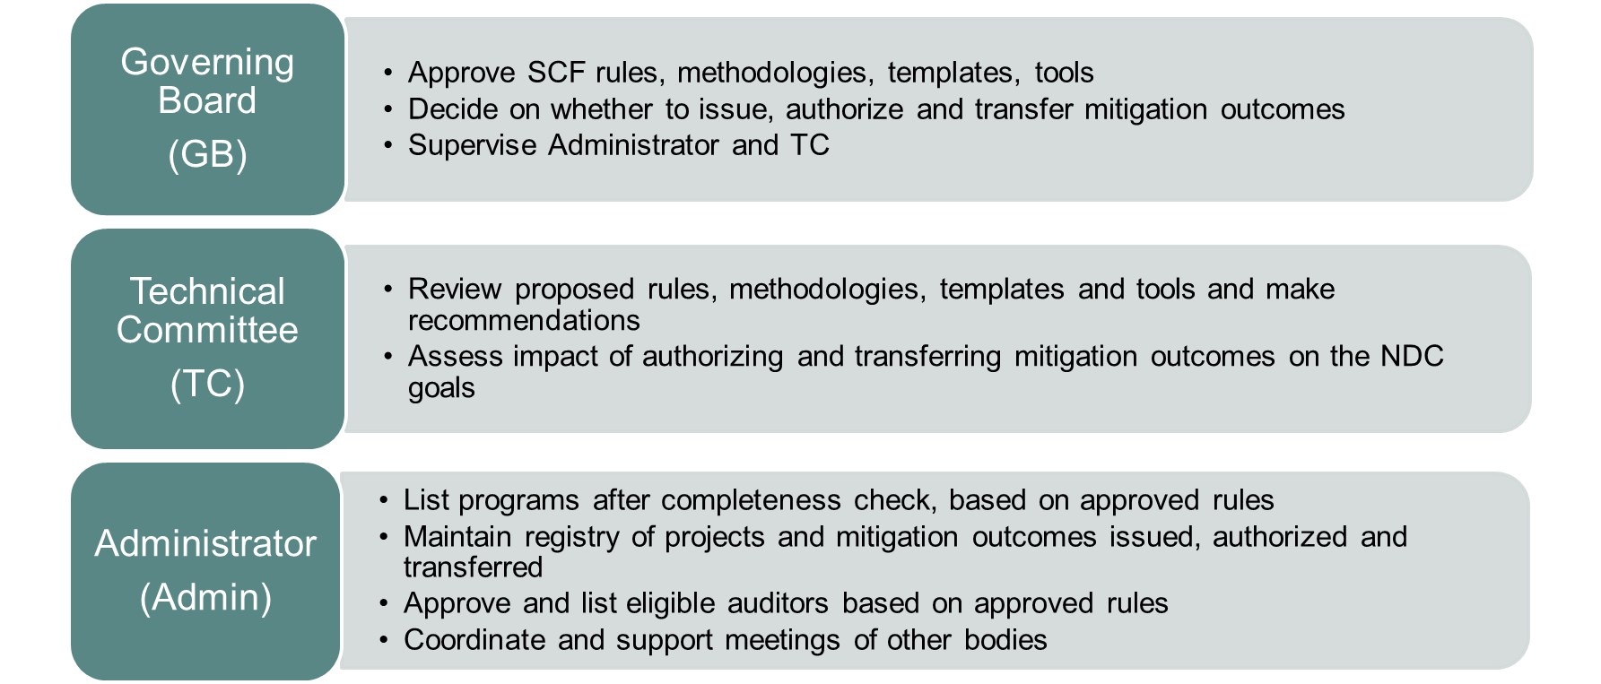

Governing Board
The Governing Board (GB) performs the policy and executive functions for the SCF and provides the overall authority and strategic direction for the SCF implementation.
Composition:
- Ministry of Environment (MoE), Director General for Climate Change (chair).
- Ministry of Infrastructure (MININFRA) (co-chair).
- Rwanda Green Fund (FONERWA).
- Ministry of Finance and Economic Planning (MINECOFIN).
- Rwanda Standards Board (RSB).
- Development Bank of Rwanda (BRD).
- Private Sector Federation (PSF)
- Rwanda Energy Group (REG) (as an observer).
The current members can continue to carry out the functions of the GB without altering their existing mandates.
The GB is appointed and supervised by the MoE. This option provides a robust and efficient structure and allows for a prompt start of the SCF, building on the existing competences and mandates in Rwanda.
Main responsibilities: The detailed list of the responsibilities during the activity cycle can be found in the terms of reference in Annex B.
- Set the principles and define the strategy for the development of the SCF.
- Approve SCF rules, methodologies, templates, and tools.
- Decide on whether to issue mitigation outcomes.
- Decide on whether to authorize mitigation outcomes for transfer and how much to transfer.
- Supervise administrative and technical functions.
- Enact regulations to codify the SCF or similar model for Article 6.
- Co-ordinate and interact with international financiers and donors.
- Approve accreditation standard (in the future).
Decision-making process: GB decisions will be made in meetings of the members. After the inaugural meeting held on 4-5 April 2023 to approve the Program Protocol and other related rules, meetings would be convened by the Administrator on an as-needed basis, including to review the lessons learned from the SCF.
Meetings:
The GB could meet periodically (e.g., quarterly, bi-annually, or as needed) to take decisions. Depending on the composition of the Board, its meeting agenda could be aligned with that of other regular meetings taking place in Rwanda. Alternatively, for the duration of the SCF, a limited number of meetings could also be agreed upon up-front to be held at relevant milestones of the SCF.
After the SCF rollout, the Government of Rwanda may opt to formally adopt a more permanent setup for the GB based on lessons learned and on the overall strategy to engage with Article 6. Accordingly, it could establish new mandates and functions. Adjustments to mandates and functions could also reflect an expansion in scope of the SCF and/or international developments on Article 6 of the Paris Agreement.

Technical Committee
To strengthen the technical capacity of the GB, the SCF includes a Technical Committee. The TC performs technical advisory functions for the SCF and provides technical inputs and recommendations to the Board.
Composition:
The TC members are drawn from the former CDM Technical Committee (Rwanda’s multi-stakeholder committee who was appointed to review CDM projects), and from elsewhere. The TC, established during the SCF pilot phase in 2020, can continue functioning per the rules of procedure of the CDM Technical Committee.
The nomination is prepared by REMA and the TC members nominated by the member institutions. Coordination is done by REMA.
Main responsibilities: The detailed list of the responsibilities during the activity cycle can be found in the terms of reference in Annex B.

- Review proposed rules, methodologies, templates, and tools and make recommendations.
- Check request for authorization versus the criteria for authorization.
- Assess impact of authorizing and transferring mitigation outcomes on the NDC (Nationally Determined Contributions) goals.

Decision-making process: The TC serves as an advisory body rather than a decision-making one and meets on an ad-hoc basis, as necessary or as suggested by the GB.
The Government of Rwanda may opt to establish a new group to house the Technical Committee and/or expand the roles of the Technical Committee in the future, based on Rwanda’s strategy for Article 6 engagement.

Administrator
The Administrator carries out most of the day-to-day administrative functions of the SCF.
Composition:
The authority in charge of environmental management (Rwanda Environment Management Authority - REMA) will serve as the administrator for the SCF.

Main responsibilities: The detailed list of the responsibilities during the activity cycle can be found in the terms of reference in Annex B.

- List programs after completeness check, based on approved rules.
- Maintain registry of projects and mitigation outcomes that are issued, authorized, and transferred.
- Approve and list eligible auditors based on approved rules (currently).
- Support the issuance, authorization, and transfer processes by conducting completeness checks on submitted documentation.
- Coordinate and support meetings of other bodies.
- Accredit auditors based on approved accreditation standard (in the future).
Decision-making process: REMA leads the Administrator and draws upon other staff as required. The Administrator operates on a continuous basis and does not have decision-making power but rather facilitates timely implementation of the steps required for SCF implementation.
As institutional capacities and resources increase, the GB may choose to widen the scope of the SCF Administrator roles, such as guiding and approving the work of the Technical Committee.

Scope and eligibility

Sectors, technologies, and activity types covered
The SCF A6 model for energy access initially focuses on improved cookstoves, and facility-scale solar PV technologies. Mitigation outcomes are claimed from the replacement of traditional firewood (e.g., three-stone fire) and/or unimproved charcoal stoves with improved-efficiency biomass-burning stoves, as well as for the displacement of fossil fuel use for lighting in rural communities.
The list of technologies and activity types covered in the SCF includes the following:
- Improved biomass-burning cookstoves with a thermal efficiency of at least 30%.
- Facility-scale solar PV systems (solar home systems).
The GB may choose, at its discretion, to include other technologies in the SCF over time. However, the approach used to calculate mitigation outcomes will need to be adjusted to fit the technologies in question.
The starting point for the SCF is the suite of technologies used by CiDev and other similar developers in Rwanda. More activity types could be added later if additional methodologies are also approved by the GB. The overall structure of the SCF has been designed to accommodate this future expansion, or even inclusion of other similar activities, after the listing and verification of the CiDev programs.

Geographic scope
The geographic scope of activities under the SCF is the entire country of Rwanda.
This SCF is specific to Rwanda and improved biomass-burning stoves and solar home systems. The methodologies of the SCF support only the technologies defined above.

Greenhouse gases covered
Mitigation outcomes under the SCF cover carbon dioxide (CO₂), methane (CH₄), and nitrous oxide (N₂O).
The technologies currently included in the SCF for Rwanda reduces emissions of CO₂, CH₄ and N₂O.

Activity Participants
During the initial phase of SCF, the only Activity Participant will be the Ministry of Finance and Economic Planning (MINECOFIN), implementing activities through the Energy Development Corporation (EDCL). Future eligibility requirements for allowing more Activity Participants will be agreed by the GB.
This section is a “placeholder”, in case Rwanda wants to move beyond the current scope. The GB will need to specify any qualifications or criteria for participation in the SCF.

Activity start date
The Activity start date is the start of actual implementation of the technologies and activities included in the scope of the Activity, supported by relevant documentation (e.g., installation reports, commissioning reports, operational reports). If no implementation has begun at the time of listing, the start date will be after the listing date and should reflect the Activity Participant’s best estimate of when implementation will start. Only activities (e.g., individual installations) starting after 1 January 2021 may be included in the SCF.

Activity cycle
The Activity Cycle for SCF activities is described in this section. First, section 4.1 explains the national crediting standard set up under the SCF, which consists of the process whereby the Government of Rwanda (i.e., the host country government) defines the steps, process, and decision criteria largely on the basis of national policies and priorities. This part of the activity cycle is similar to other existing independent crediting mechanisms but is governed domestically rather than by an independent or international body. This cycle ends at the issuance of verified mitigation outcomes. Second, section 4.2 explains the process for authorization and transfer of mitigation outcomes, which not only should reflect national policies and priorities but must also conform to the rules of Article 6 of the Paris Agreement, particularly the Article 6.2 guidance agreed at COP26 in 2021.

Figure 2: Duration of the phases of the SCF's activity cycle

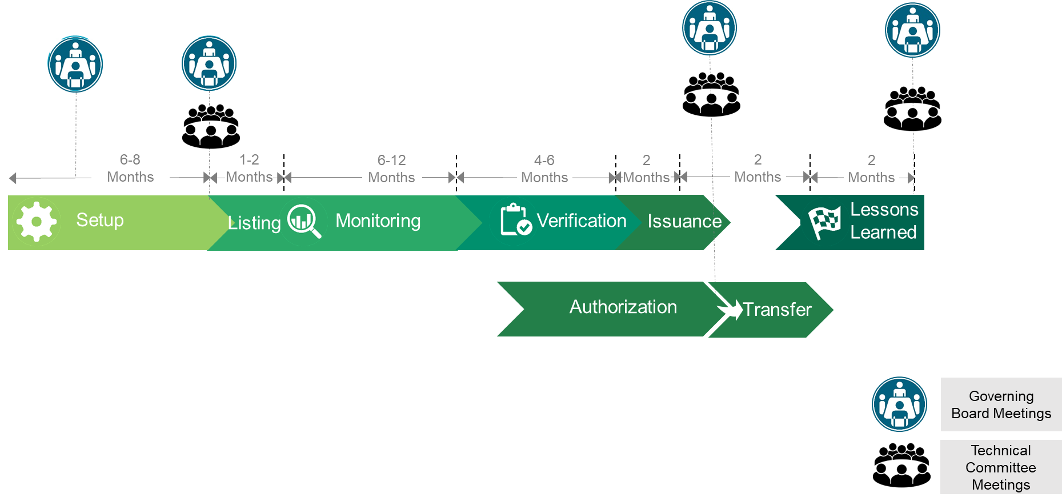

Overview of activity cycle for SCF national crediting standard
The SCF helps the country set up a national crediting standard, which will be referred to as the Rwanda SCF. The Rwanda SCF will provide procedures, governance, and tools to list projects based on the traditional project cycle used for other crediting mechanisms. The national crediting standard covers only the crediting process up to the issuance of verified emission reductions, regardless of whether these units will be used for domestic purposes or international transfers (i.e., for use toward NDCs). Section 4.2 addresses the decisions on international transfers under Article 6. Sections 4.3-4.9 present the different steps of the cycle in more detail.
The listing of programs and the verification of their performance is governed by Rwanda’s policies, while building on the experience of international carbon markets and the lessons from the SCF pilot phase in 2020. This national crediting standard is a tool for Rwanda to support projects and programs that are aligned with its priorities. The technical choices on the methodologies impact the technological solutions that are developed by stakeholders and investors under the program.
The activity cycle for the SCF national crediting standard is presented in Figure 3.
Figure 3: SCF national crediting standard activity cycle
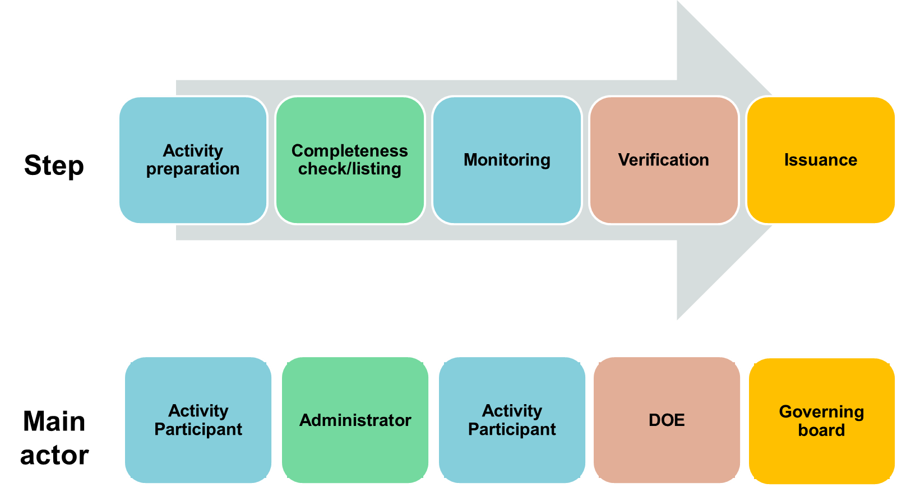

- Preparation: The Activity Participant develops a program concept and presents the program by filling in the Listing Document Template using the Listing Document Guidance.
- Completeness check and listing: The Administrator, using the Completeness Check Template and Completeness Check Guidance, conducts a completeness check on the contents of the Listing Document. If the Listing Document is incomplete, the Administrator will request changes from the Activity Participant. If the Document is complete and meets all requirements, the Administrator will inform the Activity Participant using the Listing Notification Template and will inform the GB of the acceptance of the program, and it will be listed in the official SCF registry.
- Monitoring: The Activity Participant monitors the performance of the program and uses the monitoring data and the Monitoring Calculation Tool to complete the Monitoring Report Template referring to the Monitoring Report Guidance. At the end of the monitoring period, when the Monitoring Report is complete, the Activity Participant requests the Administrator to identify a list of designated operational entities (DOEs). The Activity Participant selects a DOE from this list.
- Verification: The DOE verifies the monitoring data presented in the Monitoring Report using the Verification Report Template and Verification Guidance.
- Issuance: The Activity Participant will request issuance of emission reduction units from the Administrator. The Administrator will check the completeness of this submission, and advise the GB, which will, in turn, issue the emission reduction units into the national registry for mitigation outcomes under the account of the Activity Participant.

Overview of further steps related to Article 6.2 of the Paris Agreement
Because crediting programs implemented in the country, including in the model national crediting standard, may generate emission reduction units that could be transferred internationally, the rules that govern international transfers of mitigation outcomes under Article 6 of the Paris Agreement are also relevant for the activity cycle steps outside of the traditional activity cycle (e.g., authorization and transfer).
International transfers must follow the official accounting guidance for Article 6.2 of the Paris Agreement agreed at COP26 in 2021. This guidance requires that any mitigation outcomes first be “authorized” by the host country government (in this case the Rwandan Government) and that they then are “transferred” only after verification of the mitigation impacts using a registry option that is covered by the Article 6.2 guidance.
Authorization and transfer are political decisions because the international transfer might affect Rwanda’s NDC achievement. Rwanda may choose to develop an overall Article 6 strategy that would cover all sectors and activity types, but this process is not yet complete. Meanwhile, Rwanda may make decisions on the authorization and transfer of mitigation outcomes on a case-by-case basis. As part of the support provided under the SCF, Rwanda may define an interim process for authorization that would specifically address energy access activities. To support this, templates and draft procedures relevant for the initial energy access activities were developed by the consultant, reviewed by the TC, and approved by the GB.
In terms of process, the Activity Participant will request authorization from the GB through a submission of a request to the Administrator, and this could occur at any time after listing. The GB will then request the TC to provide an opinion on the potential impacts of authorization on Rwanda’s NDC achievement. The GB would then convene to review the TC recommendation and make the final political decision. Only when the GB reaches a positive decision would the units be formally authorized. This authorization would later also be communicated to the UNFCCC following the Article 6.2 guidance on reporting authorizations and transfers. Units that are not authorized could still be used to receive results-based climate finance (RBCF payments. Sections 4.7 and 4.8 describe this process in more detail.

Listing process
Estimated duration: 1–2 months
The process for listing is shown in Figure 4 and the steps are explained below.
- The Activity Participant should use the current version of the Listing Document Template and related Listing Document Guidance, covering general activity information, eligibility, mitigation outcomes and monitoring, stakeholder consultation, and environmental impacts. The Activity Participant should submit the completed Listing Document to the Administrator electronically.
- The Administrator will conduct a Completeness Check, referring to the Completeness Check Guidance, and notify the Activity Participant if changes are required.
- The Activity Participant will make any required changes and send the revised Listing Document to the Administrator.
- Once the Administrator judges that the Listing Document is complete, they will notify the Activity Participant and enter the data for the listed activity. The listing date will be the date that the Activity Participant sent the final version of the Listing Document to the Administrator.

Figure 4. Listing process

Monitoring requirements and process
Estimated duration: 6–12 months. Estimated 6 months for activities under implementation, and 12 months as standard monitoring period for new activities.
The process for monitoring is shown in Figure 5 and the steps are explained below.
- The Activity Participant will implement the activity.
- The Activity Participant should use the current version of the Monitoring Calculation Tool and Monitoring Report Template, as well as related Monitoring Report Guidance to present the monitoring data. A standard monitoring period after the rollout of the SCF would be 12 months, as for most other crediting standards. However, given that the crediting period can start before the listing date (see section 4.6), a shorter monitoring period would be sufficient during the rollout of the SCF to test out the templates and tools.
- Two months prior to the end of the monitoring period the Activity Participant will request the Administrator to provide a list of designated operational entities (DOE).
- The Activity Participant will then select and contract a DOE.

Figure 5. Monitoring process

Verification process
Estimated duration: 4–6 months.
The verification process is shown in Figure 6 and the steps are explained below.
- The Activity Participant will submit the completed monitoring calculation tool and monitoring report, along with all relevant supporting documentation, to the DOE.
- The Activity Participant will notify the Administrator of the initiation of the verification process.
- The DOE will conduct the verification based on the current version of the verification report template and related verification guidance.
- The DOE will submit a verification report to the Administrator, including an unqualified verification opinion. The DOE will clearly justify a positive or negative verification opinion.

Figure 6. Verification process

Issuance process
Estimated duration: 2 months.

- The Activity Participant will request issuance using the issuance request template.
- In the case of a positive verification opinion, the Administrator will check that the Verification Report and process follows the SCF rules.
- The Administrator will then forward the verification report to the GB, which will approve issuance of the mitigation outcomes.
- In the case of negative verification opinion, the Activity Participant will have a period of 30 working days in which to appeal to the GB. In this case, the GB would review the submission from the Activity Participant and the DOE and request additional clarifications and evidence, as necessary. The GB may also choose to enlist ad-hoc technical support to evaluate an appeal.
- If the GB supports the negative verification opinion, then the issuance request is rejected, and no SCF Emission Reductions (ERs) are issued by the Board.
- If the GB disagrees with the negative verification opinion, then it may approve issuance of SCF ERs based on justification and evidence gathered during the review process.
- The Administrator, or registry administrator (i.e., if the country already has one), will issue mitigation outcomes in the name of the Activity Participant in the relevant registry.
Figure 7. Issuance process

Authorization process
Estimated duration: 1 month.
- The Activity Participant submits a request for authorization to the Administrator, who will forward this request to the TC after checking the completeness of the submission.
- The TC evaluates the request against the interim evaluation criteria agreed for the SCF and the analysis of the impact of the activity on the country’s NDC.
- The GB decides whether to authorize mitigation outcomes generated by the activity for transfer, based on the TC recommendations and other political considerations. If the mitigation outcomes are not authorized, they may still be used for results-based climate finance payments (i.e., with no international transfers involved).
- The Administrator enters activity information into an appropriate authorization database.
- The authorization process could start before the verification and issuance phases, since the impact of the activity participating in Article 6 can be evaluated by the TC from the moment the listing template is received with the completeness check from the Administrator (listing phase).

Figure 8. Authorization process
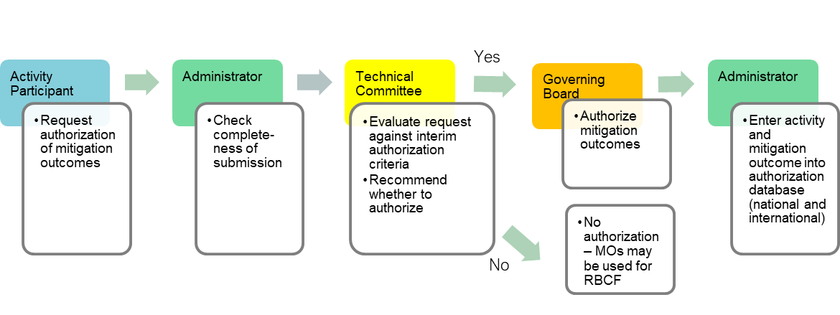

Transfer process
Estimated duration: Following the authorisation of ITMOs.
- The Activity Participant requests transfer of mitigation outcomes as internationally transferred mitigation outcomes (ITMOs).
- The Administrator checks the request for transfer against the terms of authorization.
- The GB approves the transfer.
- The Administrator executes the transfer of mitigation outcomes and enters the transfer into the relevant registry.

Figure 9. Transfer process

Crediting period
- A five-year crediting period, which may be renewed up to twice by the GB, applies to all activities.
- For activities that were not implemented prior to January 2021, the crediting period should start on the Activity Start Date (e.g., August 2022 for improved biomass-burning stoves).
- As a transition provision in the SCF, for activities under the Ci-Dev portfolio prior to 2021 that started implementation before 1 January 2021, the SCF crediting period will start on 1 January 2021 (e.g., solar home systems).
- The end of the first crediting period should be five years after the start date of the crediting period (e.g., 31 December 2025 for solar home systems or 14 August 2027 for improved biomass-burning stoves).
- Subsequent crediting periods, where approved by the GB, should align with the timeline for revising NDC commitments under the Paris Agreement.
- The GB will agree on a process for crediting period renewal, including the impact on the baseline and activity emissions calculation parameters.
The crediting period should align with the timeline of NDC revisions because updates to the NDC commitments may affect baselines for crediting.

Methodologies

Baseline and additionality principles
Improved biomass-burning stoves
Additionality for improved biomass-burning stoves is addressed using a “positive list” approach. The following technologies are considered automatically additional, based on rules developed under the CDM and other international crediting standards.

- Technology:
- Improved biomass-burning cookstoves with a thermal efficiency of at least 30%. The stoves may be portable, in-situ or multi-pot stoves.
- The stove to be replaced must be either a three-stove fire or a traditional unimproved charcoal cookstove.
- This methodology is not applicable to households switching from firewood to charcoal (i.e., households using firewood as primary fuel in the pre-program scenario that receive an improved charcoal stove in the program scenario).
- Target group: Rural and urban households using fuelwood and/or charcoal to meet their domestic cooking needs in the baseline scenario.
- Technical standards: The improved stoves must have a thermal efficiency of at least 30% measured through a water boiling test (WBT). Certification shall be done by a national standards body or a certifying body recognized by the Rwandan government, such as a certified stove testing center (http://cleancookstoves.org/technology-and-fuels/testing/centers.html).
- Double counting: The program seeking registration may not be registered under Article 6.4 of the Paris Agreement or a voluntary carbon market standard or registry.

Solar home systems
- Technology: Facility-scale solar PV systems: solar home systems.
- Target group: Rural households that were not connected to a national or regional grid or mini-grid.
- Technical standards: The program equipment must comply with the applicable national and/or international standards.
- Double counting: The program, or parts of the program, may not be registered with any other emission reduction standard or registry. If the program had historically been registered with another emission reduction standard or registry, it must not issue any further carbon credits under that standard or registry.

Methodologies and tools included in the initial program protocol
The following methodologies are included in this initial version of the program protocol:
- Methodology for improved cookstoves in Rwanda (version 1.0).
- Methodology for solar home systems for Rwanda (version 1.0).
Methodologies, and the related templates and guidance documents, may be updated periodically by the TC and GB.
Additional methodologies approved later will be added to this list.

Process for approval of additional methodologies
The GB may, at a later date, agree on a process for approving additional methodologies, which would be developed and/or reviewed by the TC.
A new methodology development process will be needed to include additional methodologies, so the GB may ask the TC to develop and/or review this issue, if there is interest in more methodologies and technologies. This could include simply accepting methodologies already approved under other standards (e.g., CDM, VCS, Gold Standard) or could also include development of new methodologies specific to the Rwanda SCF.

Sustainable development
Activities in the SCF should also include sustainable development co-benefits. Activities with strong sustainable development benefits are more readily embraced by the stakeholders and have a good chance for successful implementation. During the rollout of the SCF, the activity should highlight potential benefits and indicators that could be used to measure them, but monitoring will not be required. When requesting approval, they may refer to the sustainable development criteria and process required by the Rwandan government in the template template developed under national carbon market framework. Examples of direct socio-economic effects include employment creation, positive impacts on disposable income for low-income households, foreign exchange effects, technology transfer and diffusion. Local environmental benefits could include reduction in local air, water, and other pollution. The activities may also highlight the contribution to the Sustainable Energy for All goals in Rwanda.

Stakeholder participation and engagement
The SCF program should provide an opportunity for a public consultation with local stakeholders. The consultation process – including the identification of stakeholders, presentation of the project design, solicitation of comments, and answering those comments - should follow relevant national guidelines. The process should also explicitly say that the program will be used to generate quantified emission reductions (i.e., not simply be a presentation of the underlying technology).
The stakeholder consultation may occur after listing but must be completed prior to the start of verification. A record of the consultation process and outcomes shall be included in the monitoring report so that it can be checked by the DOE.
Where an SCF activity is already registered under the CDM or a voluntary carbon market standard, the original stakeholder consultation process conducted as part of that registration is sufficient and no additional consultation is required.

Accreditation and DOEs
During the SCF rollout, any one of the following entities may serve as a DOE:
- Companies accredited as DOEs by the CDM Executive Board under “Sectoral scope 3. Energy demand” (i.e., for improved cookstoves) and “Sectoral scope 1: Energy industries” (i.e., for solar energy).
- Companies accredited as accredited independent entities (AIEs) under the Joint Implementation Supervisory Committee under “Sectoral scope 3. Energy demand” (i.e., for improved cookstoves) and “Sectoral scope 1: Energy industries” (i.e., for solar energy).
- Companies accredited as validation/verification bodies by the Verified Carbon Standard under “Sectoral scope 3. Energy demand” (i.e., for improved cookstoves) and “Sectoral scope 1: Energy industries” (i.e., for solar energy).
While the SCF GB or other Rwanda crediting programs may wish to enlarge this list to include more local certification organizations in the future, the time constraints for the SCF do not allow for new accreditation processes specifically for the SCF. Local entities could, however, be involved in verification as observers and participate in capacity-building workshops run by the DOEs.

Registry and public access to information
The SCF will provide publicly available information on the status of any listed SCF Activity. During the initial rollout of the SCF, however, this will be simple, because only one activity will be listed. Upon successful listing of an SCF Activity, the Administrator will publish the approved Listing Document on the REMA website. At the completion of verification, the Administrator will also publish the completed Monitoring Report and Verification Report, as well as the date when the mitigation outcomes were issued by the GB. Reporting on authorization and transfer will be covered by Rwanda’s Article 6 reporting processes required by the Paris Agreement.
If the SCF is extended or expanded, an online activity database may be needed, but not with only one activity. Note that this activity database is different from a registry that tracks tradeable units. The SCF will make relevant activity documentation and decisions available to the public on the website of REMA.

Fees
In the future, the GB may choose to levy fees during listing and/or certification to support the costs of administering the SCF.

Templates and guidance documents
The section lists the templates and guidance documents that are used in the SCF. If any of this documentation is revised, the most recent version will appear on the SCF Rwanda website or another designated website.
Templates and guidance documents for improved biomass-burning stoves:
- Listing document template for improved biomass-burning stoves.
- Completeness check template for improved biomass-burning stoves.
- Listing notification template for improved biomass-burning stoves.
- Monitoring calculation tool for improved biomass-burning stoves.
- Monitoring report template for improved biomass-burning stoves.
- Verification report template for improved biomass-burning stoves.
- Verification guidance for improved biomass-burning stoves.

Templates and guidance documents for solar home systems:
- Listing document template for solar home systems.
- Completeness check template for solar home systems.
- Listing notification template for solar home systems.
- Monitoring calculation tool for solar home systems.
- Monitoring report template for solar home systems.
- Verification report template for solar home systems.
- Verification guidance for solar home systems.

Templates and guidance documents for all SCF activities:
- Issuance request template.
- Issuance completeness check template.
- Authorization request template.
- Authorization assessment template.

The website will also include the current version of approved methodologies. For the rollout of the SCF, this will be the methodologies “Improved cookstoves in Rwanda” and “Solar home systems for Rwanda.”

Complaints and appeals
The proposed SCF governance arrangements aim to provide transparent and objective complaints and appeals procedures for any stakeholder (Activity Participants, methodology developers and other stakeholders). The SCF could include formalized procedures for individuals who wish to make a complaint about its performance, a verification body’s performance, or register any suspected non-compliance of an activity under the SCF approach. It would also allow an Activity Participant to appeal an authorization decision.

A complaint is an objection or an expression of dissatisfaction by any stakeholder about to a decision taken by the SCF GB or Administrator or a claim that the SCF rules have had an unfair, inadvertent, or unintentional adverse effect. Complaint letters could be addressed to the SCF Administrator. Any complaints and appeal procedures could be formalized and handled by the SCF Administrator. The SCF GB would communicate the decision regarding the resolution, including the reasons for the decisions. The SCF GB would prepare a written response, which REMA would provide to the appellant. The SCF GB’s decision would be final and binding. In the case that the issue cannot be solved to the satisfaction of the parties within a pre-determined amount of time, an appeal procedure external to the SCF governance framework could be initiated.
The GB may choose to review these provisions.

Support to stakeholders
As part of their overall support, the World Bank has engaged the consulting team to support the listing of the first activity under the SCF. This means that the consulting team will assist the Activity Participant in filling in the listing template, as well as the monitoring template for verification. While the monitoring period until verification could span six months, the consulting team will request more regular updates from the Activity Participant through the local consultant to ensure there are no gaps in record keeping and to catch any data gaps or inconsistencies early in the process. The consulting team will also provide regular feedback to the Administrator (REMA), the World Bank, and the GB of the SCF during the monitoring period.
In the development and implementation of the SCF, the consulting team will also engage with key stakeholders in the energy and climate change field in Rwanda. This will include several types of support:
Discussion on the roadmap and program protocol: The consulting team drafts the roadmap (i.e., this document) and an accompanying program protocol, which details the rules for the SCF, like other carbon market standards. The first discussions present the SCF approach and highlight how it can be tailored to Rwanda and to the efficient and clean cooking stove and the solar home systems sectors. The full drafts of the program protocol and accompanying templates were circulated to key stakeholders prior to the second mission in April 2023. This includes the full GB and TC members. Comments were solicited via email and face-to-face meetings with key stakeholder during the second mission to Rwanda (4-5 April 2023), where TC and GB meetings were held.
Individual meetings with members of TC and GB prior to or after their first meeting: In addition to the more formal meetings and workshops mentioned above, the local consulting team may meet with individual members of key institutional structures. These meetings will introduce the more detailed content of the program protocol and methodology, as well as explain the overall process of the SCF implementation.
Launch of SCF and presentation of activities: As part of the formal launch of the SCF, the TC and GB for the SCF convened to approve rules for the program during the meetings in April 2023. Formal listing of the activity would only take place after the launch workshop, based on the listing procedures. Given that the activities of the Activity Participant have started implementation, local stakeholder consultation will be required. This consultation would focus on the proposed activity and on how the Activity Participant activity and SCF could pave the way for crediting activities for Rwanda under the Paris Agreement. The consulting team would also meet with the Activity Participant staff to review monitoring systems and available data even before the listing of the activity, to ensure that the monitoring and verification rules for the SCF reflect local needs.
Presentation of the results and lessons from the SCF rollout: After the GB decisions on issuance and authorization, the consulting team will prepare a list of lessons learned from the SCF rollout, assessment of its relation to Article 6 of the PA and impacts including a comparison of the earlier CDM process with the SCF process. The TC will also meet to review these lessons and provide their input. These lessons will be discussed with stakeholders for their feedback and additional ideas on how Rwanda could engage in international carbon markets. This final workshop would include, in addition to the stakeholders from earlier meetings, potential Activity Participants that might engage with the SCF or other international crediting mechanisms.

Version history
Version | Date | Contents revised
1.0 | 06/04/2023 | Initial adoption

- Glossary
Term | Definition
Activity participant | The public or private entity that is the developer or owner of the activity (i.e., project or program) and/or has the legal right to the mitigation outcomes.
Activity | The activity (i.e., projects or programs) described in the activity documentation under the CDM, SCF, Article 6.4 mechanism, or another crediting mechanism, capable of generating emission reductions under a crediting mechanism.
Acquiring Party | Country government receiving authorized mitigation outcomes, ITMOs, as part of a transfer between two or more country government.
Authorization | The host Party’s decision to make mitigation outcomes eligible for transfer to another country or for other mitigation purposes, based on the Article 6.2 guidance.
Crediting mechanism | A policy instrument used to generate and issue emissions reduction or emission removal units to mitigation activities, in recognition of quantified and verified emissions reductions or removals. Crediting mechanisms may be governed by international agreements (e.g., the CDM under the Kyoto Protocol), national law (e.g., a domestic crediting mechanism) or by independent private or non-profit bodies (e.g., the voluntary carbon market standards).
Designated operational entity (DOE) | The accredited entity designated under the relevant crediting mechanism, which performs verification of the activity performance and eligibility.
Internationally transferred mitigation outcomes (ITMOs) | Mitigation outcomes that are authorized and transferred out of the host country, for use by another country towards its NDC, for use in other international mitigation systems (e.g., CORSIA for international aviation) or for use for other purposes (e.g., voluntary carbon markets).
Issuance | Creation of ER units for an activity in the pending account (if applicable), trustee’s account or other appropriate registry account pursuant to the protocols or procedures of the relevant crediting framework(s) specified in the Emission Reductions Purchase Agreement (ERPA).
Host Party | The country where the activity is located as specified in the ERPA.
Listing | The process by which the Administrator of the SCF confirms that an activity meets the eligibility requirements of the SCF and accepts the activity as a part of the SCF and eligible to generate GHG reductions.
Listing document | The document that provides relevant technical information about an Activity and is submitted to the Administrator by the Activity Participant for the purposes of listing such an activity under the SCF.
Mitigation outcomes | Emission reductions and emissions removals measured in tonnes of carbon dioxide equivalent (tCO₂e).
SCF emission reduction (ER) | A verified and issued ER unit pursuant to the SCF rules, which is equal to one metric ton of CO₂e, calculated in accordance with approved SCF methodologies.
Transfer (of ITMOs) | The change of legal ownership of mitigation outcomes from one Party (current country or organization with ownership) to another Party (country or organization).

- Terms of reference for SCF governing bodies
This annex presents the terms of reference for the governing bodies of the Article 6 Model for Energy Access (SCF) in Rwanda. More details on the overall institutional and governance structure for the SCF rollout are presented in the “SCF Roadmap for Rwanda”. The same institutional arrangements can support future Article 6.2 transactions.

Conformation of the SCF governing bodies
The legal process of formalizing the country's governing bodies around the cooperative approaches under Article 6 of the Paris Agreement will be carried out by the A6 governance framework project developed by the country with UNDP support.
The SCF GB and TC are appointed and supervised by the MoE. For the confirmation of the SCF bodies, REMA will submit a formal request to the institutions that are part of the TC and the GB for senior management (e.g., Minister or Director General, as appropriate) to officially appoint a representative for these specific purposes. Any change to these representatives will be done through an official communication from the relevant institution to REMA.

Governing Board (GB)

Mandate
The GB performs the policy and executive functions for the SCF and provides the overall authority and strategic direction for the SCF implementation. The GB should be established or appointed by the Rwanda Government.

Main responsibilities
The GB has the following responsibilities:
- Set the principles and define the strategy for the development of the SCF.
- Approve protocol, templates, and tools.
- Decide on whether to issue mitigation outcomes.
- Decide on whether to authorize mitigation outcomes for transfer and how much to transfer.
- Supervise the Administrator and Technical Committee (TC), request TC advice, and approve recommendations from TC.
- Certify emission reductions.
- Review lessons learned.
- Decide on future development of SCF and international transfers of mitigation outcomes.
- Approve accreditation standard (in the future).

Additional responsibilities related to tasks during activity cycle (see list of processes in section 4):
- In the case of negative verification opinion where the Activity Participant appeals, the GB would review the submission from the Activity Participant and the DOE and request additional clarifications and evidence, as necessary. The GB may also choose to enlist ad-hoc technical support to evaluate an appeal.
- If the GB supports the negative verification opinion, then the Activity is rejected and there are no verified mitigation outcomes.
- If the GB disagrees with the negative verification opinion, then it may certify the mitigation outcomes.
- The GB decides whether to authorize mitigation outcomes generated by the activity for transfer, based on the TC recommendations and other political considerations. If the mitigation outcomes are not authorized, they may still be used for results-based climate finance payments (i.e., with no international transfers involved).
- The GB approves the transfer after the Administrator has checked the request.
- The GB decides on a process for crediting period renewal, including the impact on the baseline and activity emissions calculation parameters

Composition
The GB should consist of a limited number of key members to enable efficient decision making. To the extent possible, the Board should rely on existing structures in the country, for example established for implementation of the CDM in the past. The following stakeholders are best positioned as members of the Board.
- Taking decisions affecting the crediting of emission reductions in Rwanda:
Stakeholder: Rwanda’s authorities responsible for climate change policy and authorities in charge of the sector covered by the SCF should be involved.
Rationale: Decisions taken by the GB would impact international climate change cooperation and potentially also Rwanda’s ability to implement its NDC.
- Taking decisions related to the economic sectors (energy access programs for the specific case of the SCF) in Rwanda:
Stakeholder: Rwanda’s authority(ies) responsible for promoting energy access technologies.
Rationale: Decisions taken by the GB would impact how carbon and climate finance can support energy access technologies.
- Overseeing actual financial flows involved in the SCF rollout:
Stakeholder: Rwanda’s national finance authorities.
Rationale: Financial flows occurring from transactions of carbon credits should be governed and approved by the responsible authorities
- Promote decision-making considering the capacities of the private sector:
Stakeholder: Private sector association(s).
Rationale: The energy access sector, as well as this specific activity, could engage private sectors stakeholders. To avoid any conflict of interest, a representative should not be from individual companies that might have a financial interest in the outcomes of the SCF rollout. Private Sector Federation (PSF) Chamber of Commerce and Services could play this role, because it represents a variety of commercial and industrial interests across various sectors. PSF can play this role in other stakeholder bodies as well.
- Additional members that could be involved
Stakeholder: Civil society.
Rationale: Involving civil society in the GB can be an option to increase the credibility of the SCF. There could also be civil society participation in the TC (as complement or as an alternative).

Decision-making process
GB decisions will be made in meetings of its members. After the inaugural meeting to approve the Program Protocol and other related rules, meetings would be convened by the Administrator on an as-needed basis, including to review the lessons learned from the SCF.

Technical committee (TC)

Mandate
The TC performs the technical functions for the SCF and provides technical input and recommendations to the GB.
The composition of the TC may be modified by the GB according to the specific needs of the sectors or activities participating in the SCF.

Main responsibilities
The Committee has the following responsibilities:
- Review and recommend: All rules for the SCF, including methodologies, MRV requirements, templates, and tools.
- Review and comment on lessons learned and on future proposals for additional standardized methodological approaches and GHG accounting and MRV-related issues beyond the initial activities.
- Check request for authorization versus the criteria for authorization.
- Assess impact of authorizing and transferring mitigation outcomes on the NDC goals.
- Advise, as requested, the GB on the role of crediting and transfers in the context of the NDC, to further support Rwanda’s NDC implementation.
- Respond to ad-hoc requests from the GB.

Additional tasks during activity cycle (see list of processes in section 4):
- The TC will review all the documents for the SCF.
- It would be asked for specific inputs on an ad-hoc basis by the GB during any step of the activity cycle.
- The TC receives the request for authorization of mitigation outcomes from the Administrator and evaluates it against the interim evaluation criteria agreed for the SCF and the analysis of the impact of the activity on the country’s NDC.

Composition
The TC should include relevant technical experts, inside and outside of government, on sector-specific mitigation technologies as appropriate (in the case of the SCF this will include experts on energy access technologies), climate policy, and mitigation analysis:
- Stakeholders: National experts that are familiar with Rwanda’s national circumstances and climate frameworks as well as key economic sectors for mitigation (in the case of the SCF stakeholders familiar with energy efficiency and renewable energy).
- Rationale: National experts would lend additional credibility to the SCF.
If there is an existing multi-stakeholder committee serving to review CDM projects or to conduct technical review of the NDC, this body could be tasked with becoming the SCF TC and provide technical recommendations.

Decision-making process
The TC serves as an advisory body rather than a decision-making one and meets on an ad-hoc basis as necessary or as suggested by the GB. While the TC reviews all the documents for the SCF implementation, it does not have a direct role in the program cycle, except when asked for specific inputs on an ad-hoc basis by the GB.

SCF Administrator

Mandate
The Administrator carries out most of the day-to-day administrative functions of the SCF.

Main responsibilities
The Administrator has the following responsibilities:
- Convene meetings of the TC and GB.
- Lists projects and undertakes completeness checks (during listing and certification).
- Maintains a registry of projects and mitigation outcomes that are issued, authorized, and transferred.
- Approves and lists eligible auditors based on approved rules.
- Supports the issuance, authorization, and transfer processes by conducting completeness checks on submitted documentation.
- Accredits auditors based on approved accreditation standard (in the future).
- Organizes GB meeting for verification, and forwards templates to the GB.
- Contributes to review of SCF and lessons learned.

Tasks during activity cycle (see list of processes in section 4):
- The Administrator will conduct a completeness check during listing and notify the Activity Participant if changes are required.
- Once the Administrator judges that the listing document template is complete and meets all requirements, the Administrator will inform the Activity Participant using the Listing notification template and will inform the GB of the acceptance of the program.
- Also, when the Administrator judges that listing document template is complete, the Administrator will enter the data for the listed program activity into the registry.
- The Administrator will inform the Activity Participant of the list of accredited DOEs.
- In the case of a positive verification opinion, the Administrator will check that the verification report follows the SCF rules.
- The Administrator will then forward the verification report to the GB, which will certify the mitigation outcomes.
- The Administrator will record the mitigation outcomes achieved in the registry (see section 9) and notify the national authorities charged with tracking NDC implementation of the mitigation outcomes certified.
- Once the GB has approved the issuance of MOs, the Administrator, or registry administrator (i.e., if the country already has one), will issue mitigation outcomes in the name of the Activity Participant in the relevant registry.
- Once the Activity Participant submits a request for authorization, the Administrator will forward this information to the TC, after checking the completeness of the submission.
- The Administrator enters activity information into an appropriate authorization database.
- The Administrator receives from the Activity Participant requests to transfer mitigation outcomes as ITMOs.
- The Administrator checks the request for transfer against the terms of authorization and submits information to the GB for approval.
- After the decision of the GB, the Administrator executes the transfer of mitigation outcomes and enters transfer into the relevant registry.

Composition
The Administrator role would typically be filled by the authority in charge of environment and climate change. This could be REMA, which currently serves as the Article 6.4 mechanism, and the national designated authority or focal point for national engagement with the Green Climate Fund, which would be able to use and build on existing structures and experiences from the CDM.

Decision-making process
The Administrator operates on a continuous basis and does not have decision-making power but rather facilitates timely implementation of the steps required for SCF implementation.

Governing board, technical committee and administrator
For the purposes of the SCF, the co-chair will be the ministry in charge of infrastructure as the institution involved in energy access projects.
As specified by the ISO Tier Guidance published in 2018, available at: https://cleancooking.org/news/10-16-2018-voluntary-performance-targets/.
See exception for activities in the CiDev portfolio prior to 2021 in section 4.9
Relevant data for the registry at the time of listing would include Activity Participant, program start date, program crediting period start date, listing date, technologies included and estimated annual mitigation outcomes.
For the full list of DOEs, see http://cdm.unfccc.int/DOE/list/index.html.
For the full list of AIEs, see http://ji.unfccc.int/AIEs/List.html.
For the full list of VVBs, see http://verra.org/project/vcs-program/validation-verification/.
Unlike the CDM process for Programmes of Activities, where new groups of sub-projects or households need to be added under “Component Program activity (CPA)”, under the A6MEA the program includes all the activities implemented so far in a given year. In the improved cookstove example, this means that all of the operational stoves that have been installed as of a given year (since the Program Start Date) are part of the program.
SCF focuses on projects related to energy access, thus institutions representing energy/forestry sector will be represented among the governing bodies. For future Article 6 implementation, representatives from additional sectors will likely be included into some of the bodies described in the document.

